4.7 More Equations and Inequalities

Solve Rational Equations
A rational equation is an equation that involves one or more rational expressions (fractions where the numerator and denominator are polynomials).

Steps to Solve Rational Equations:
- Identify the rational expressions in the equation.
- Find the Least Common Denominator (LCD) of all the rational expressions.
- Multiply both sides of the equation by the LCD to eliminate the denominators.
- Simplify the resulting equation.
- Solve the resulting equation (usually a linear or quadratic equation).
- Check for extraneous solutions by substituting back into the original equation to make sure no denominators become zero.

Example 1: Solve the Rational Equation

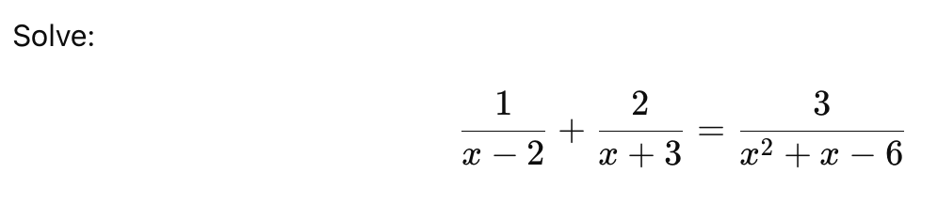
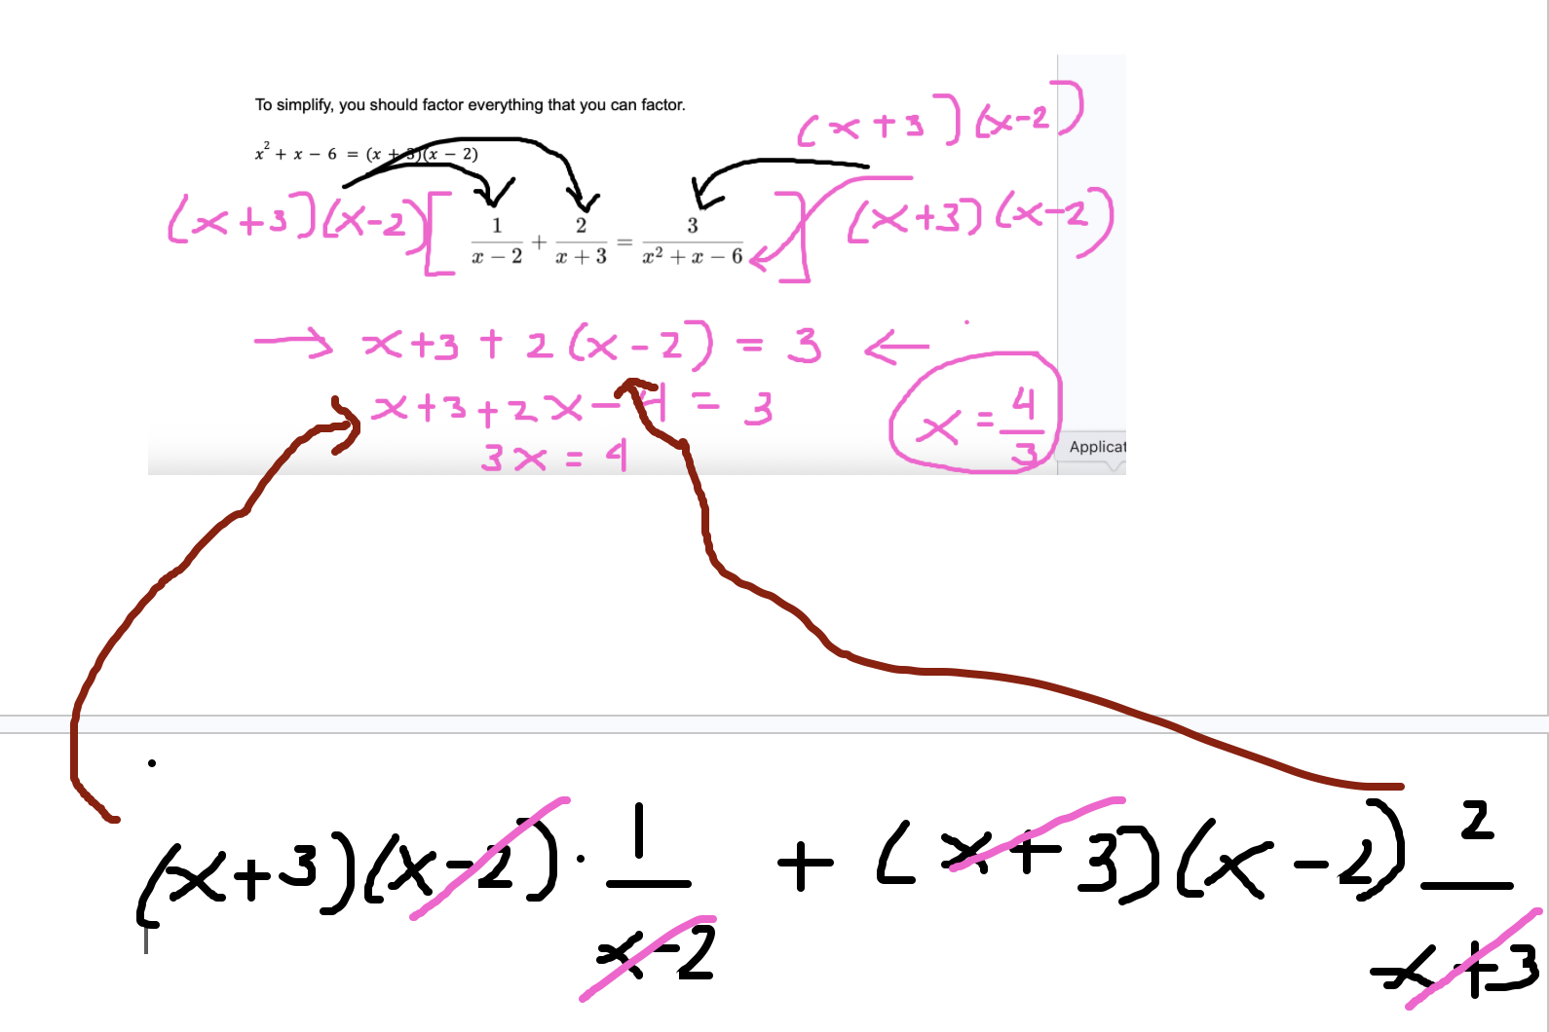

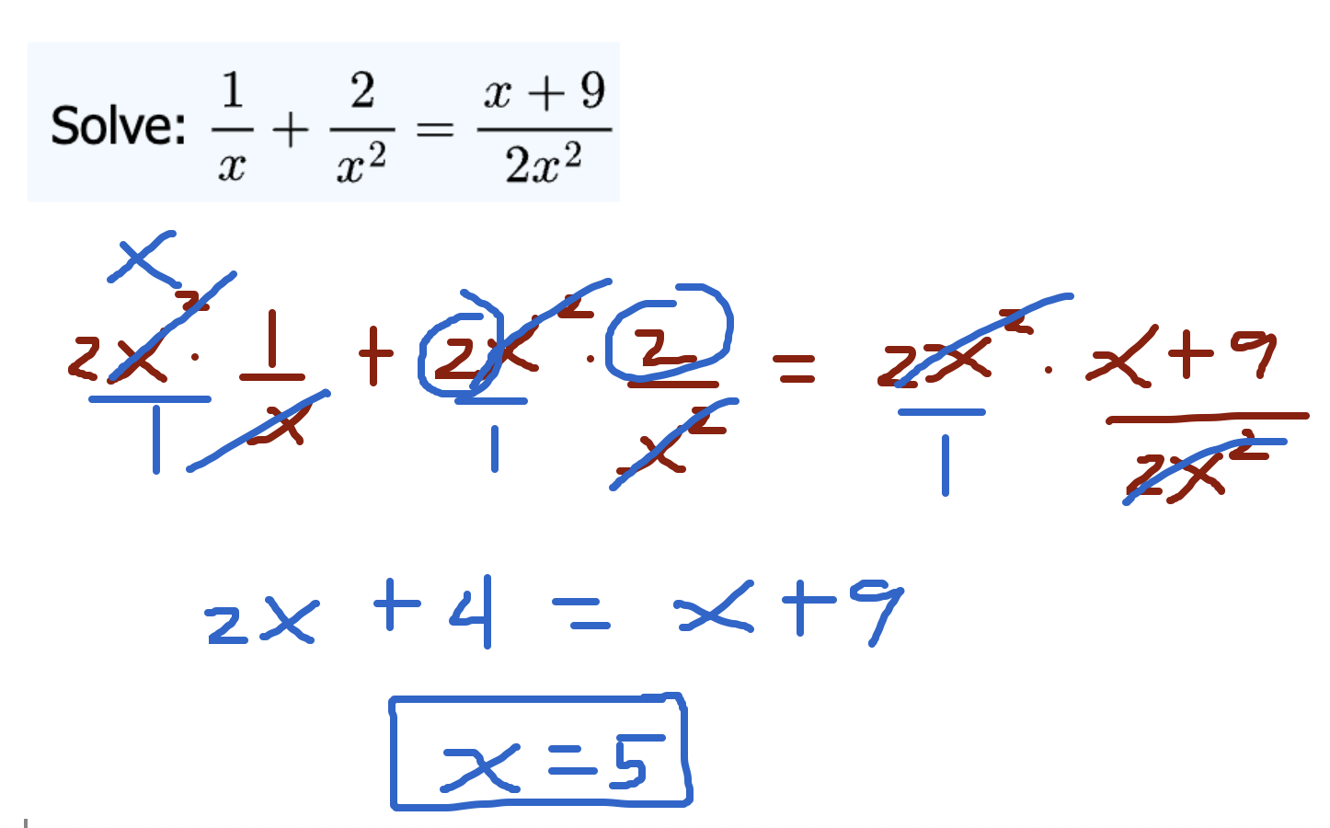

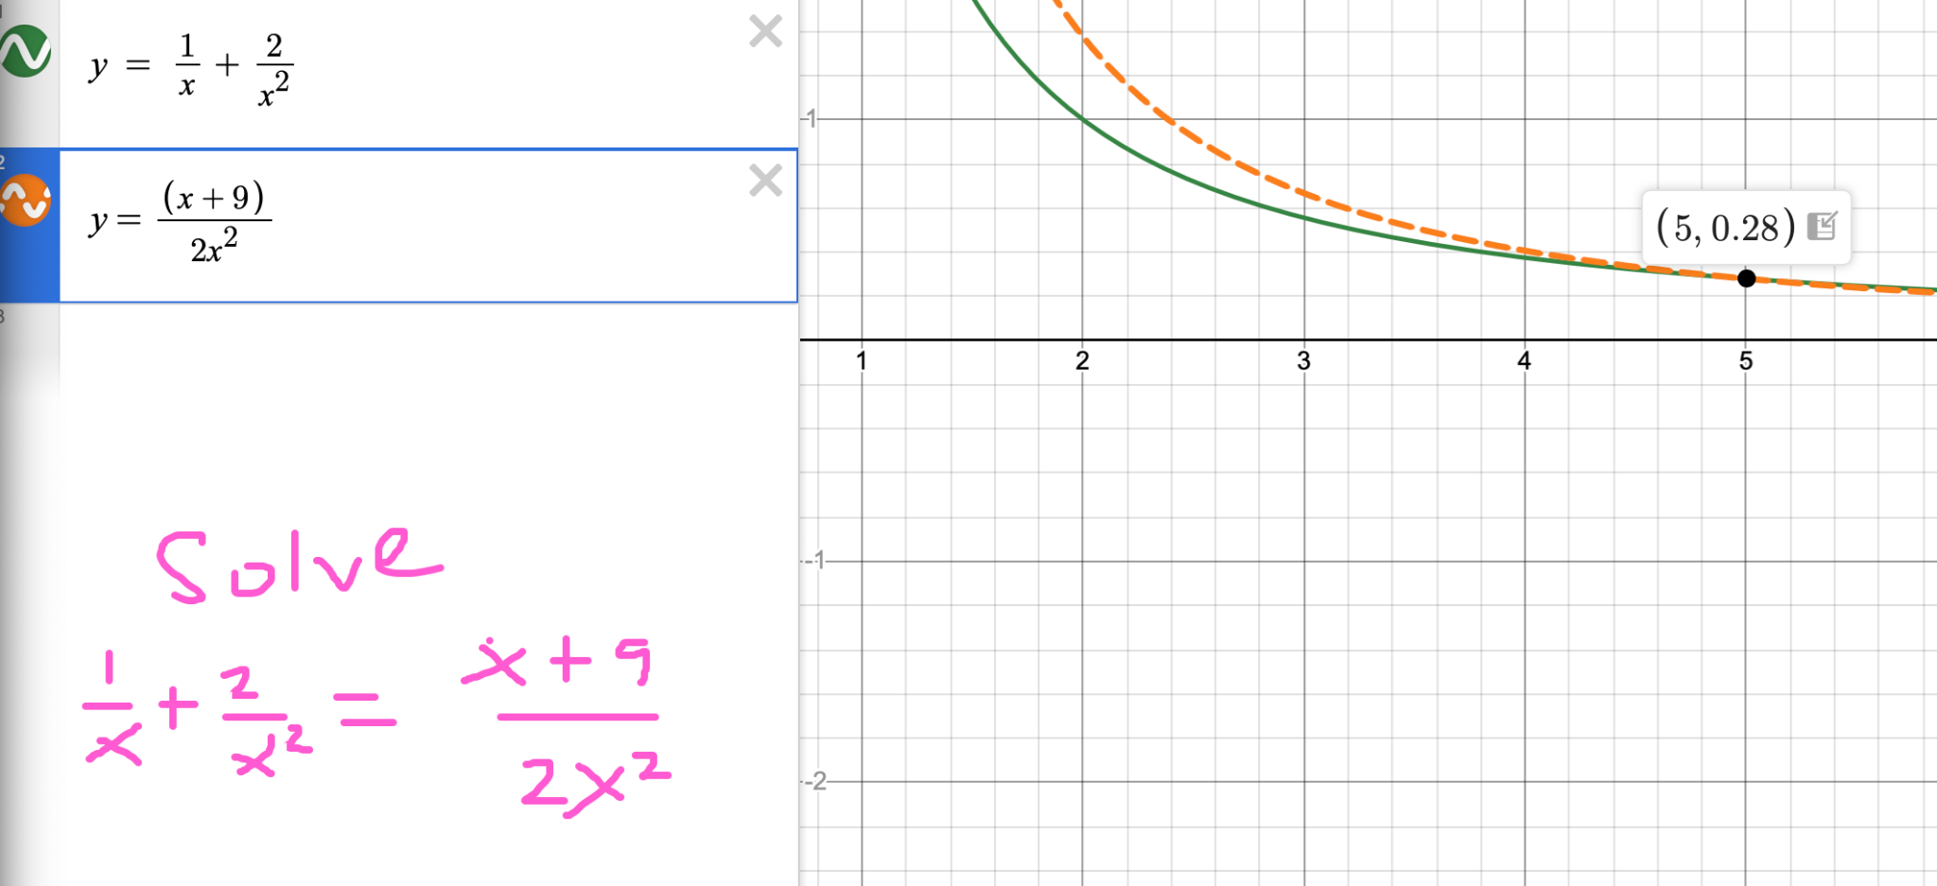

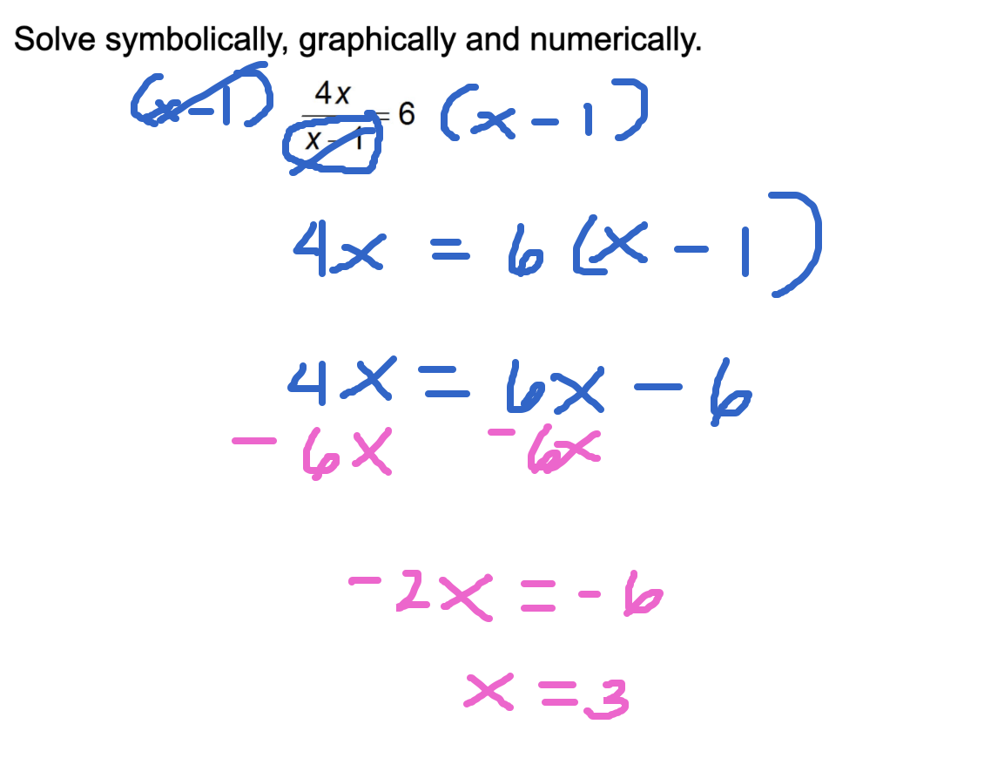

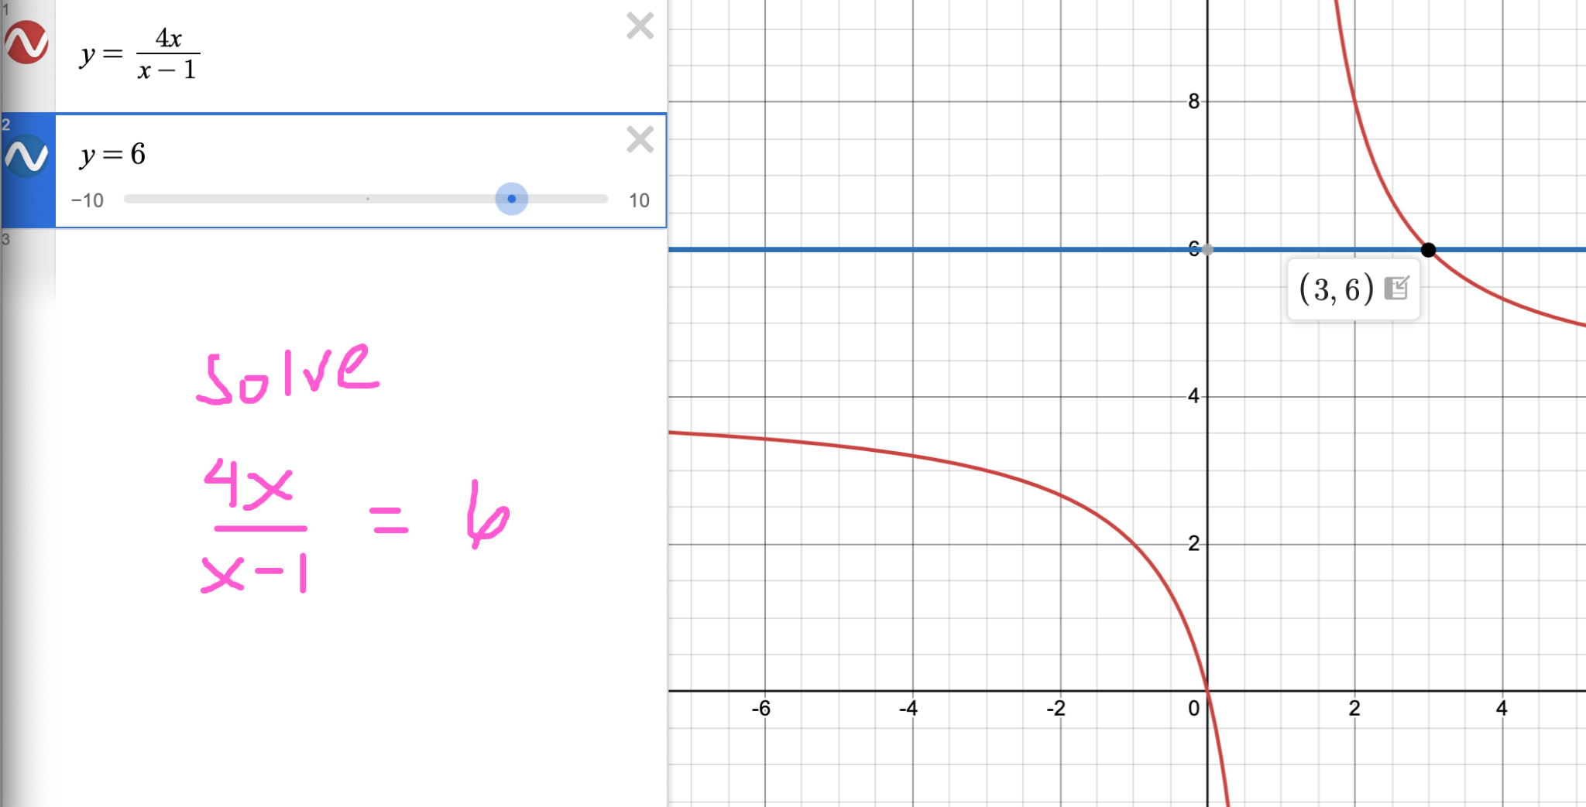

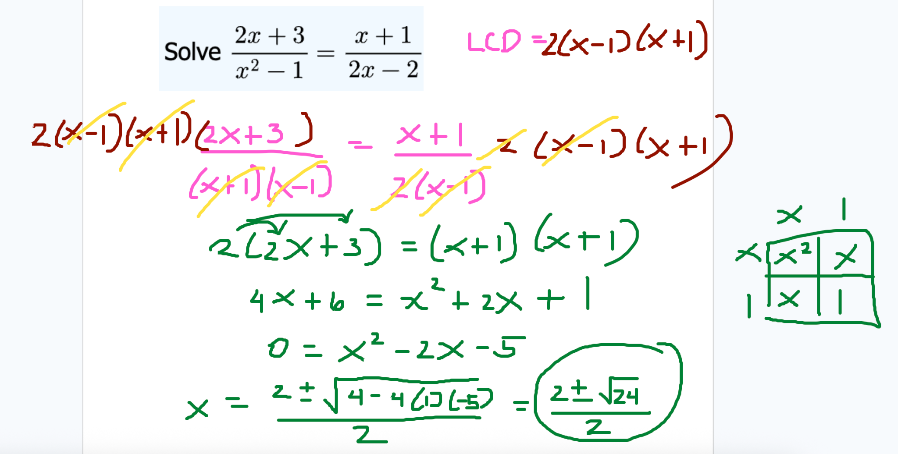

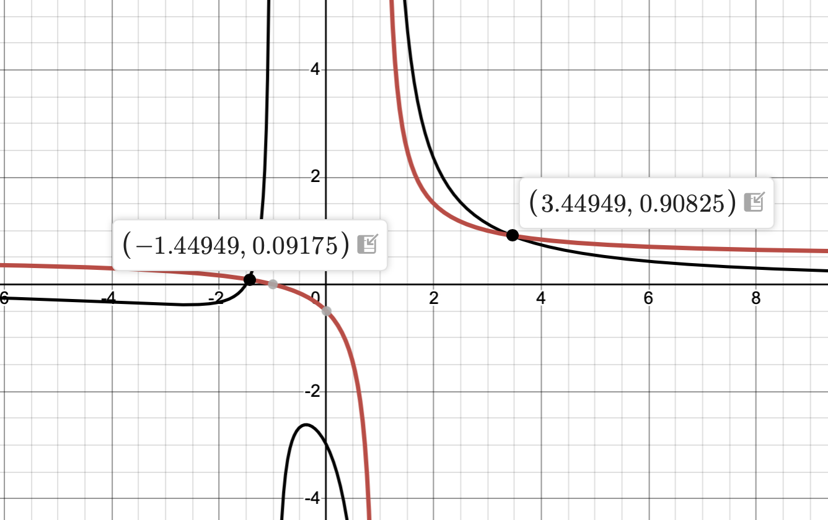

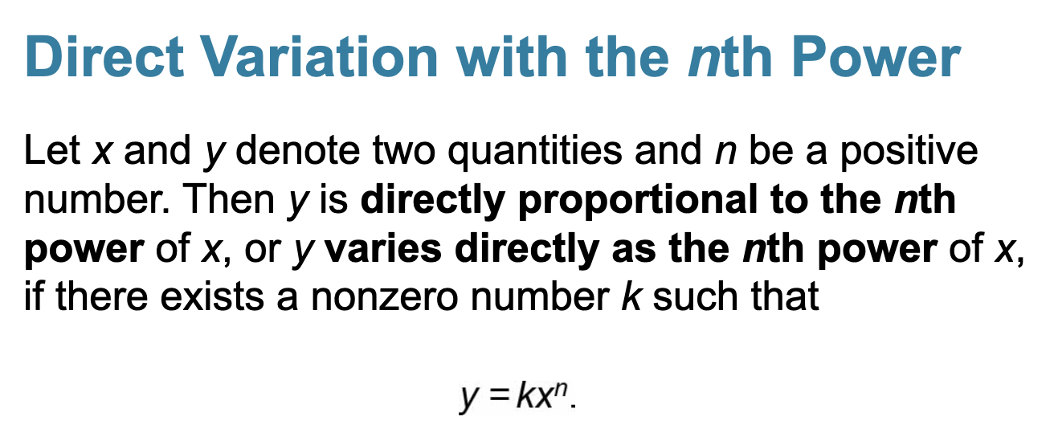

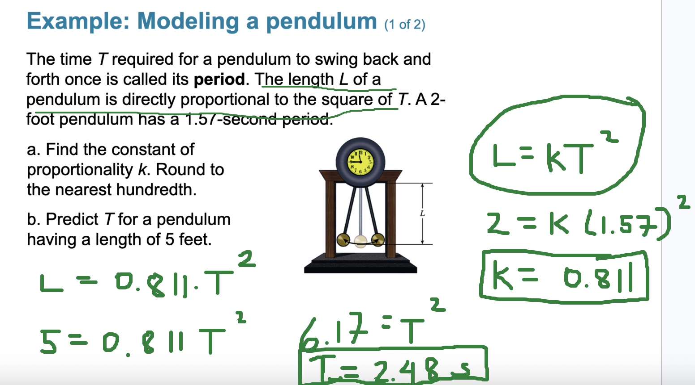

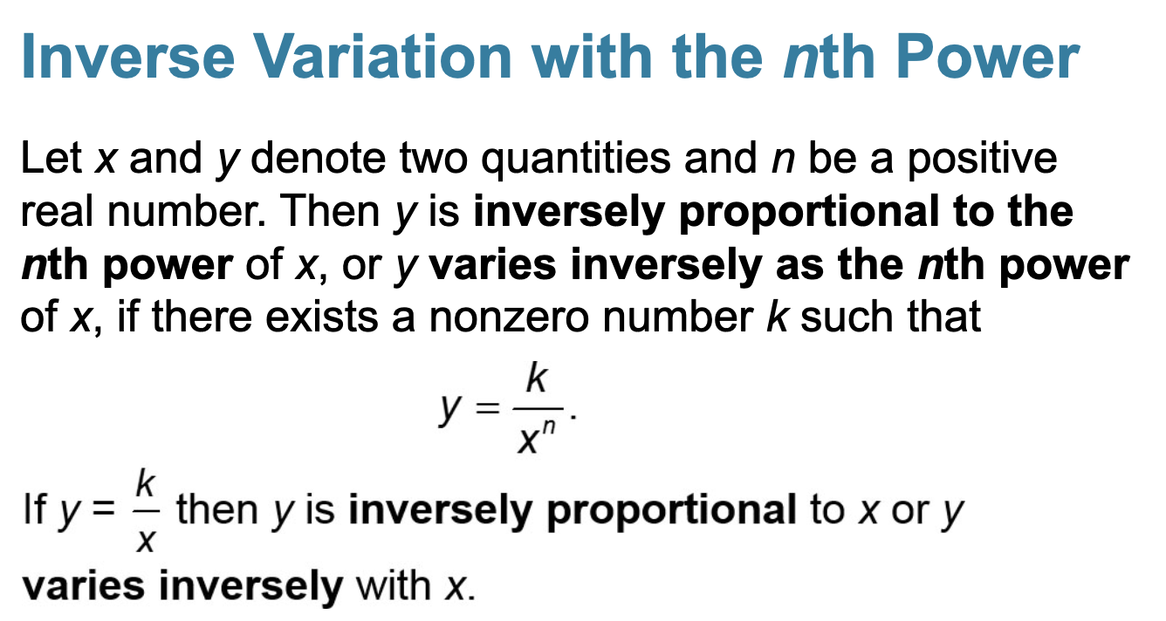

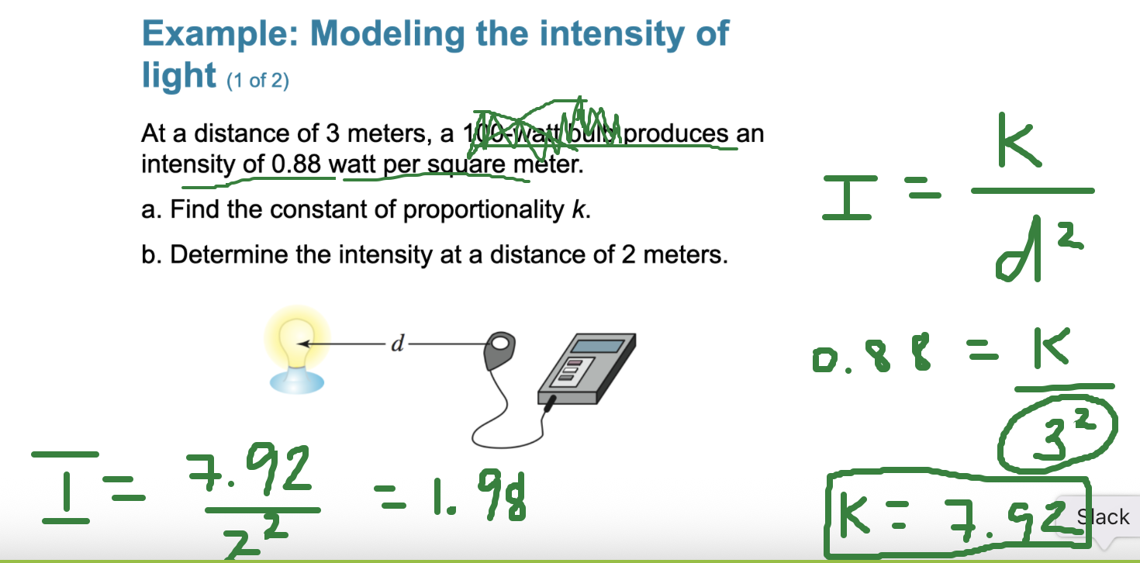

Solve Polynomial Inequalities
Polynomial inequalities are inequalities that involve polynomials, and solving them typically involves finding the intervals where the polynomial is greater than, less than, or equal to zero.

Steps to Solve Polynomial Inequalities:
- Set the inequality equal to zero:
Rearrange the inequality so one side equals zero, and the other side is either greater than, less than, or equal to zero.
- Factor the polynomial:
Factor the polynomial expression on one side of the inequality.
- Find the critical points:
Solve the factored equation f(x) = 0 to find the critical points (x-values where the expression changes sign).
- Test intervals:
Use the critical points to divide the number line into intervals. Test each interval to determine whether the inequality is true or false within that interval.
- Write the solution:
The solution will be the intervals where the inequality holds true.
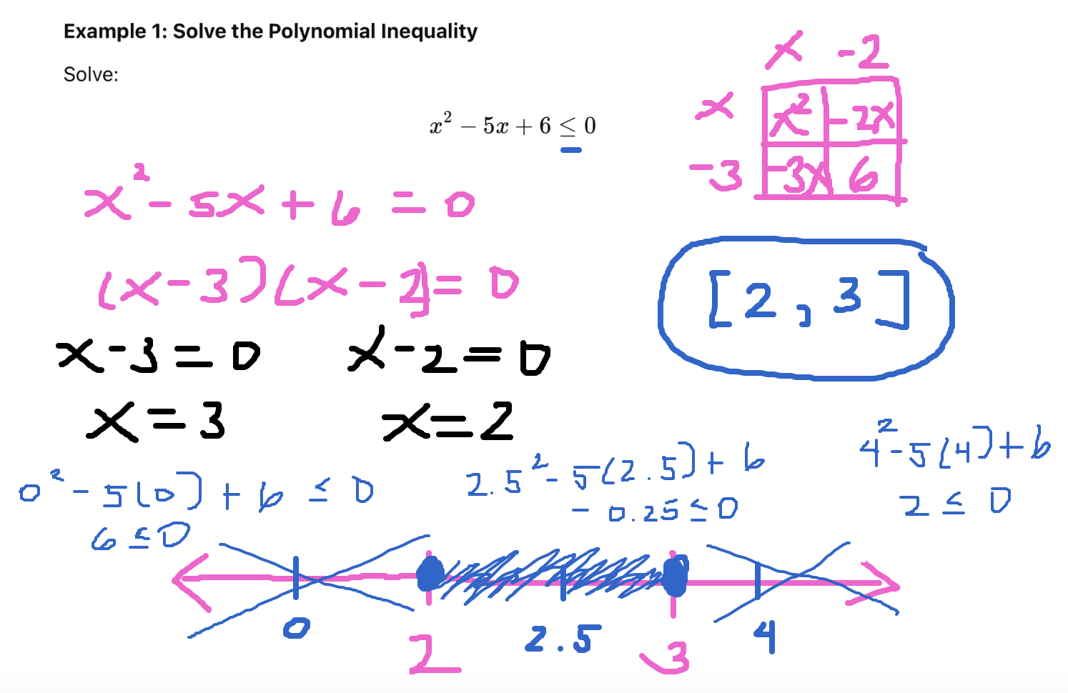

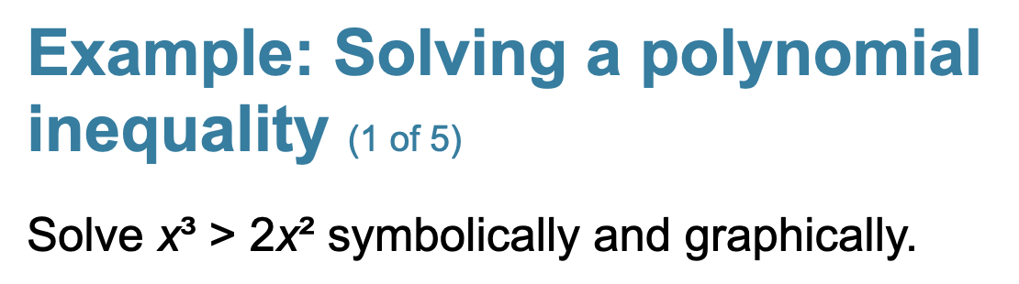

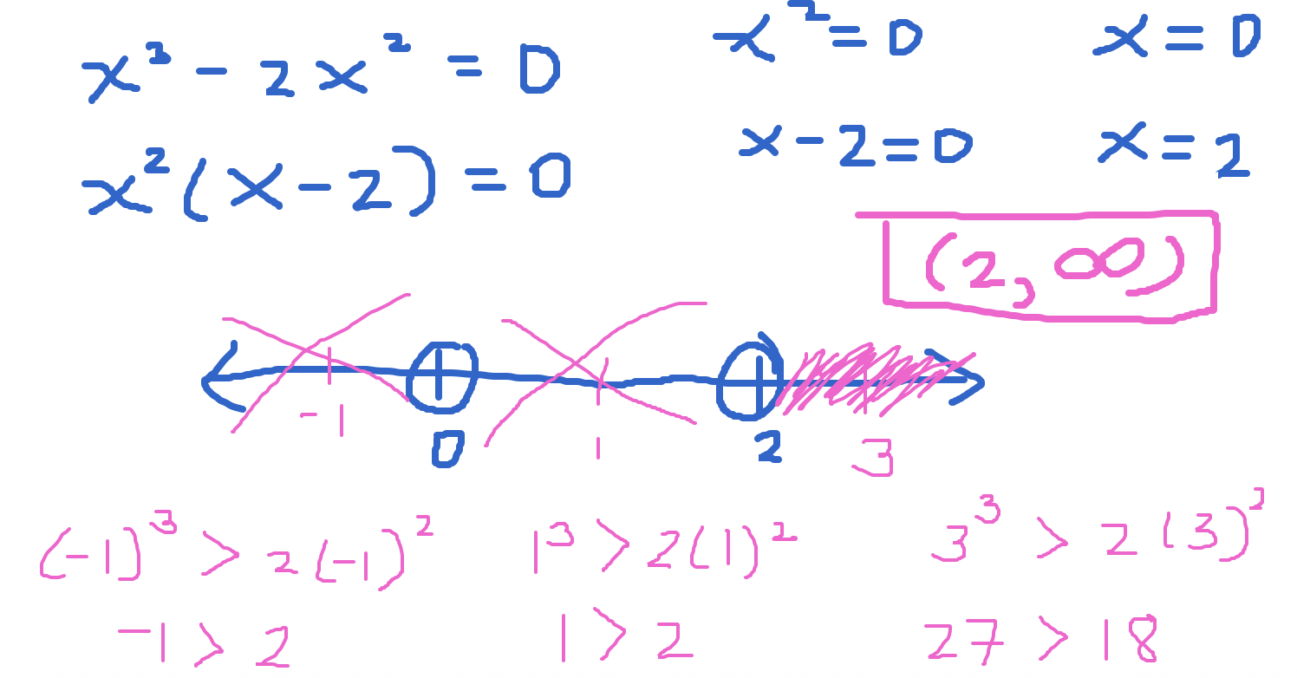

Graphically. For what values of x is $x^{3}$ above $2x^{2}$

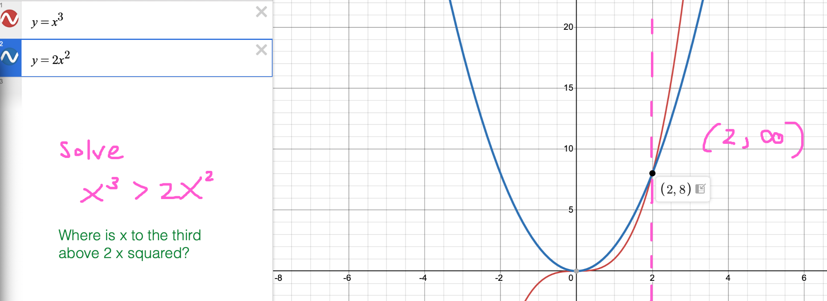

Solve Rational Inequalities
Rational inequalities involve rational expressions, and we solve them in a similar way to polynomial inequalities.

Steps to Solve Rational Inequalities:
- Set the inequality in standard form:
Make sure the rational expression is on one side of the inequality and everything else is on the other side.
- Find the critical points:
Set the numerator and denominator equal to zero and solve for x to find the critical points.
- Test the intervals:
The critical points divide the number line into intervals. Test each interval to determine where the inequality holds true.
- Write the solution:
The solution will be the intervals where the inequality is satisfied.
